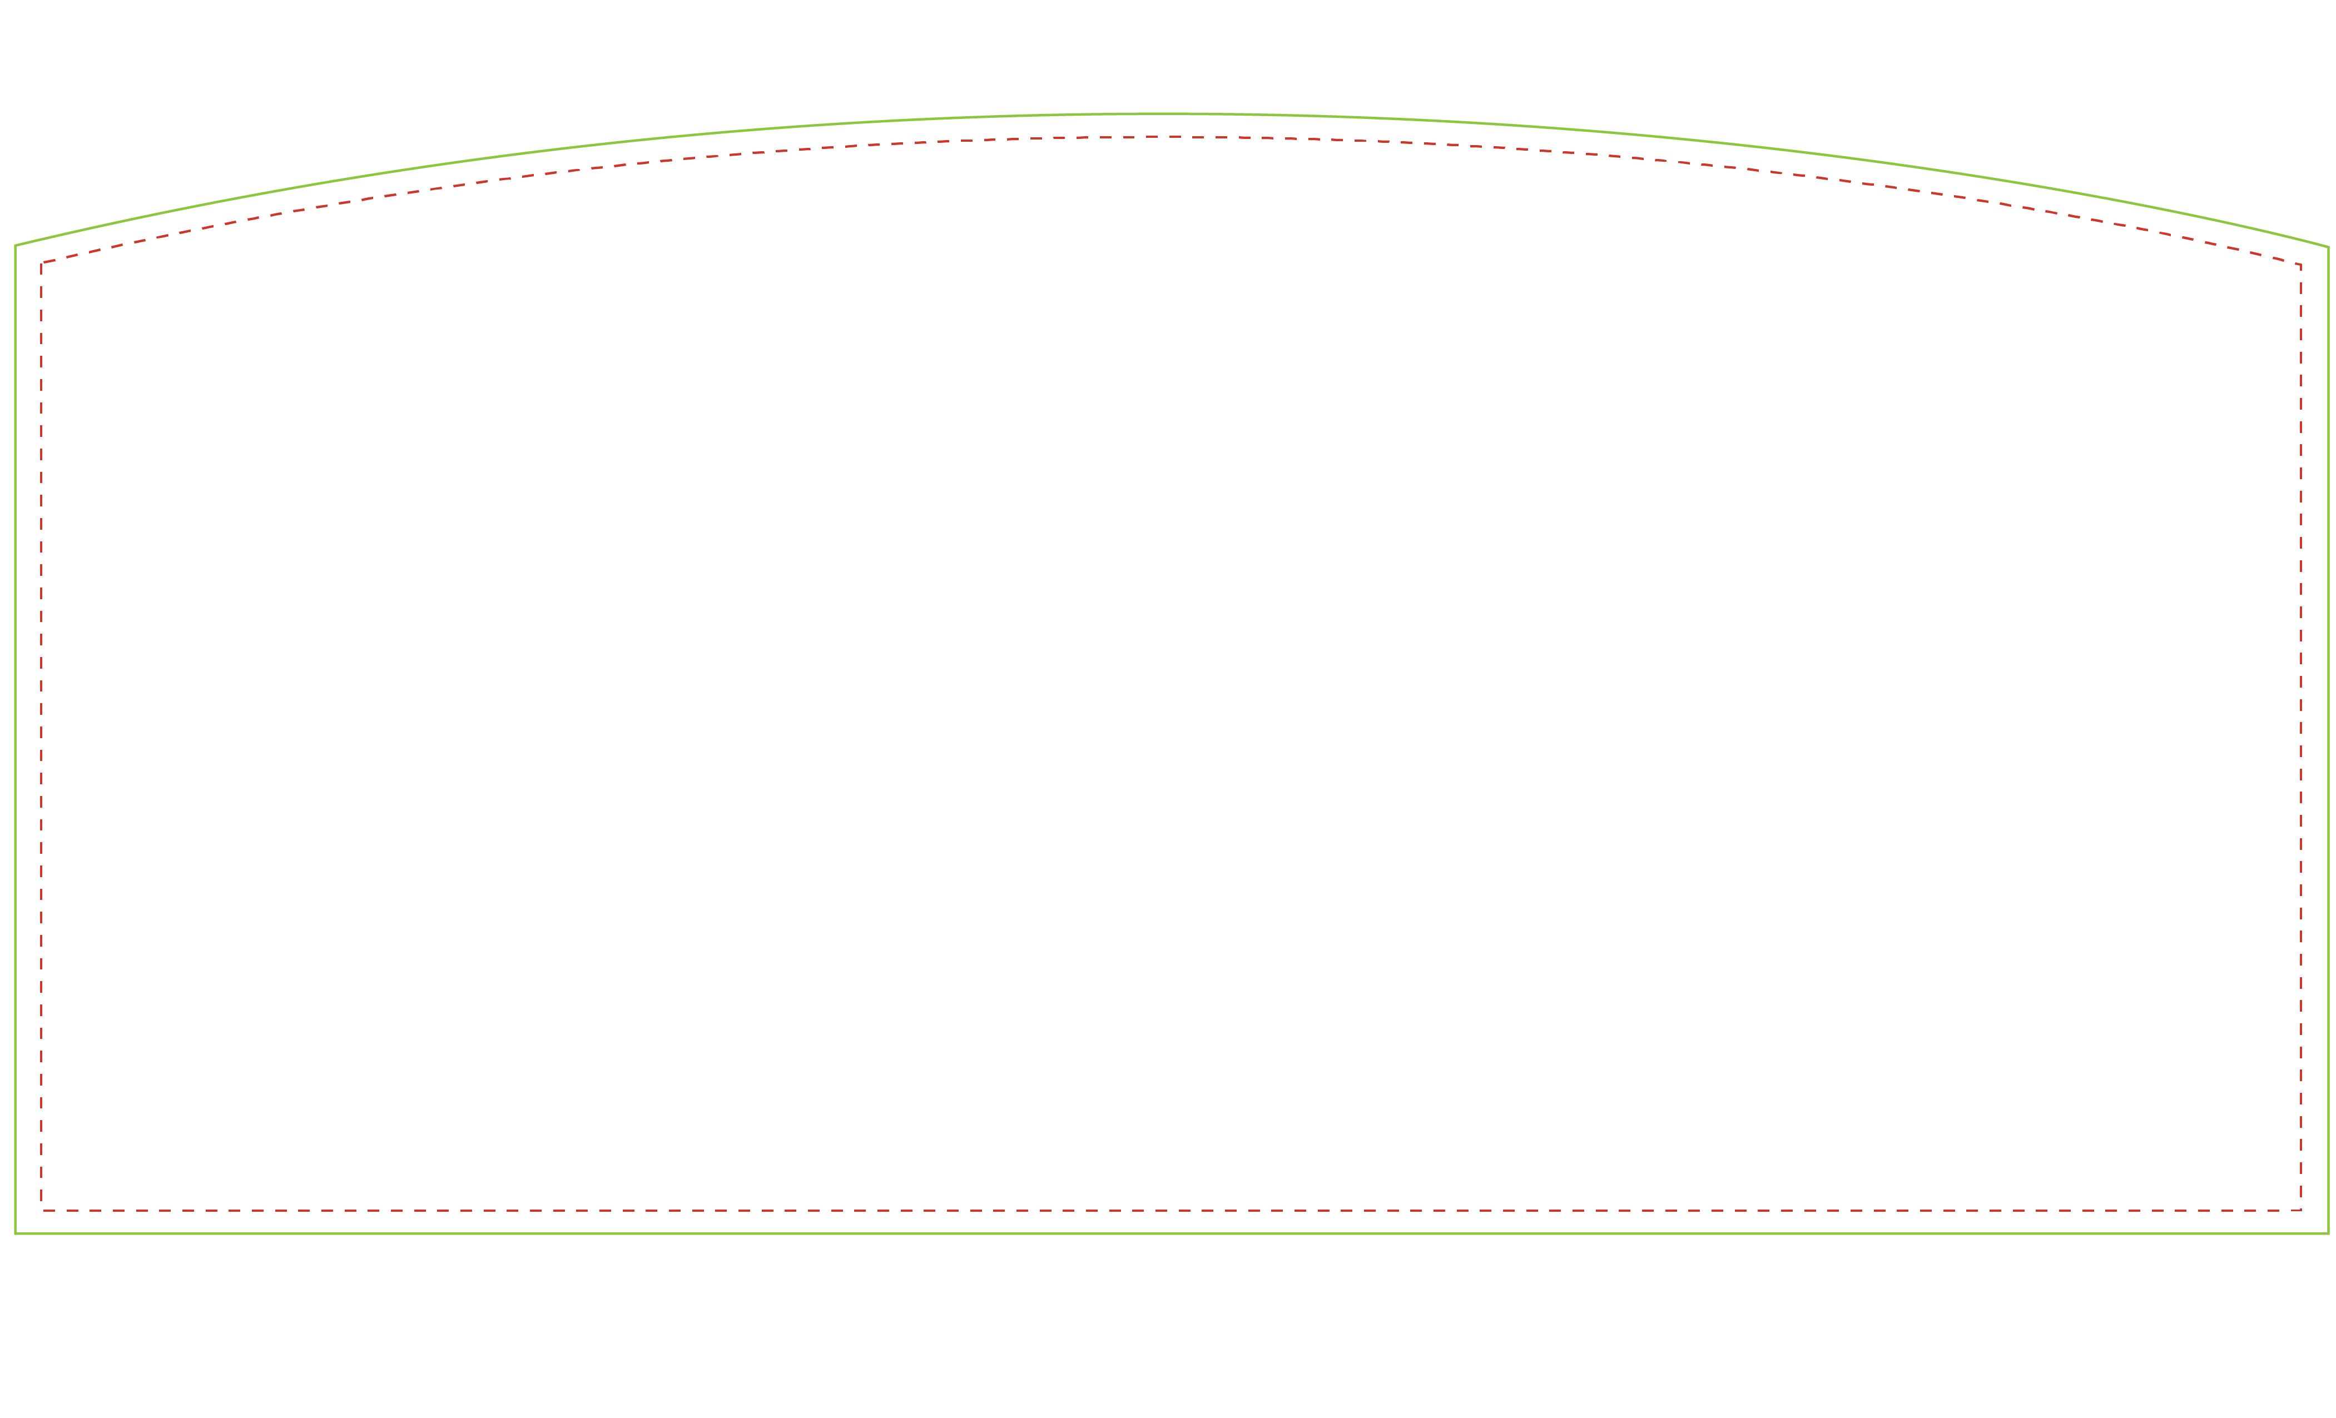

Customize the header – Right click on image, choose format picture to change color. Make a text box in header to add type. | Print on 8.5 x 11 paper. Print as “do not scale” for correct size. | Cut on dotted line.
Prize
Drop -
Header
.,

