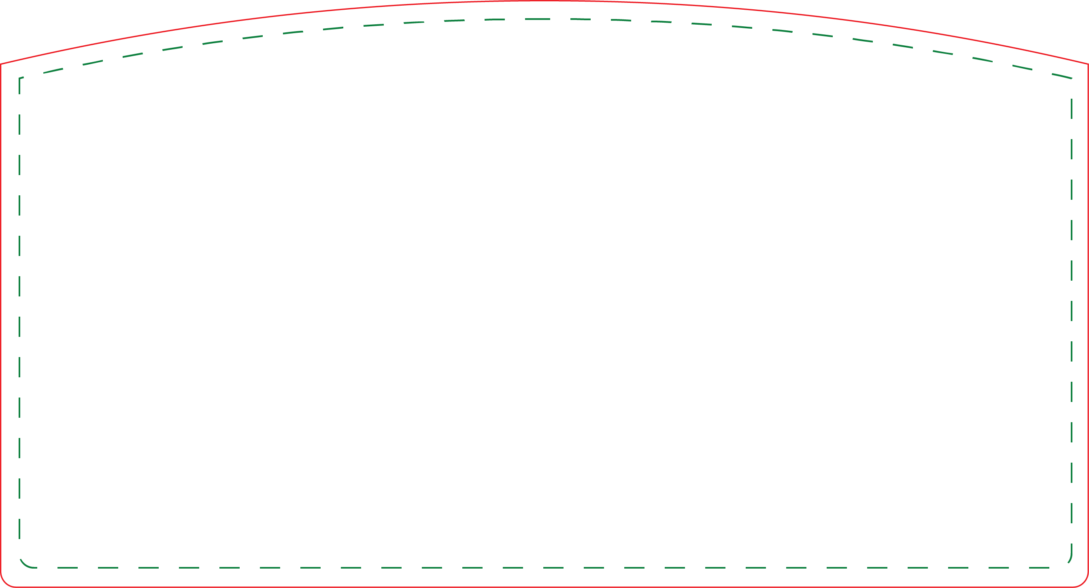

- Customize the header – Right click on image, choose format picture to change color. Make a text box in header to add type.
- Print on 8.5 x 11 paper. Print as “do not scale” for correct size.
- Cut on dotted line.
- Have FUN!

Mini Prize Drop
Header

