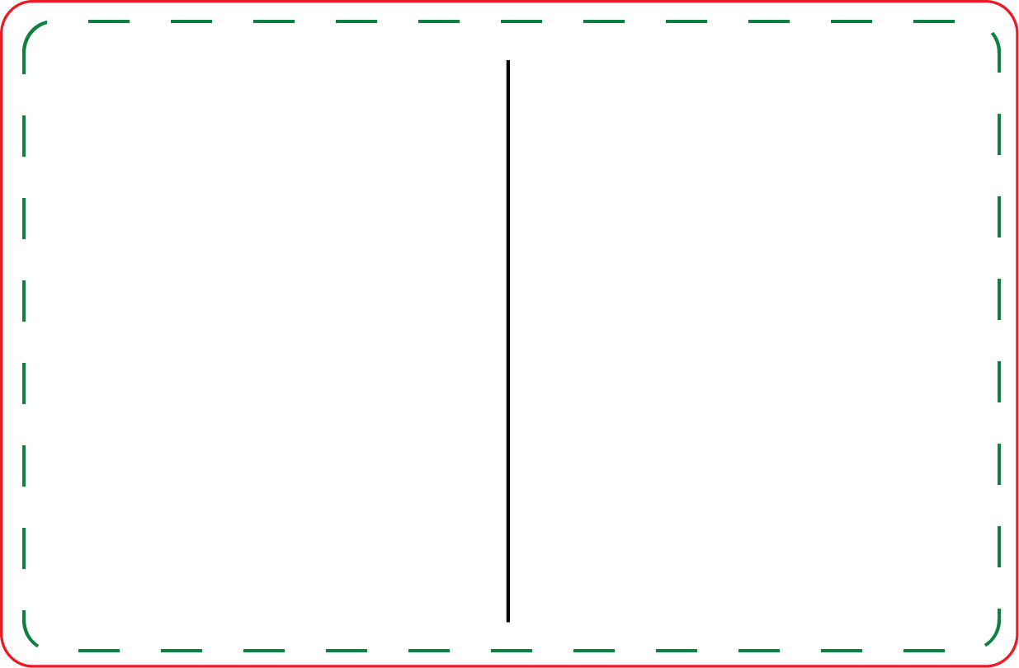

- Customize Prize inserts – Right click on insert, choose format to change color.
- Print on 8.5 x 11 paper – print at “do not scale” for correct size
- Cut on dotted line
- Have FUN!!!
Mini Prize Drop - Prizes

